Admin

Panel

**Technology: -** PHP, HTML, Java Script.

**URL of Panel: -** http://delainetechnologies.com/haywood_drinks/app/admin/

**Username: -** admin

**Password: -** admin@123

**Admin Panel Login**

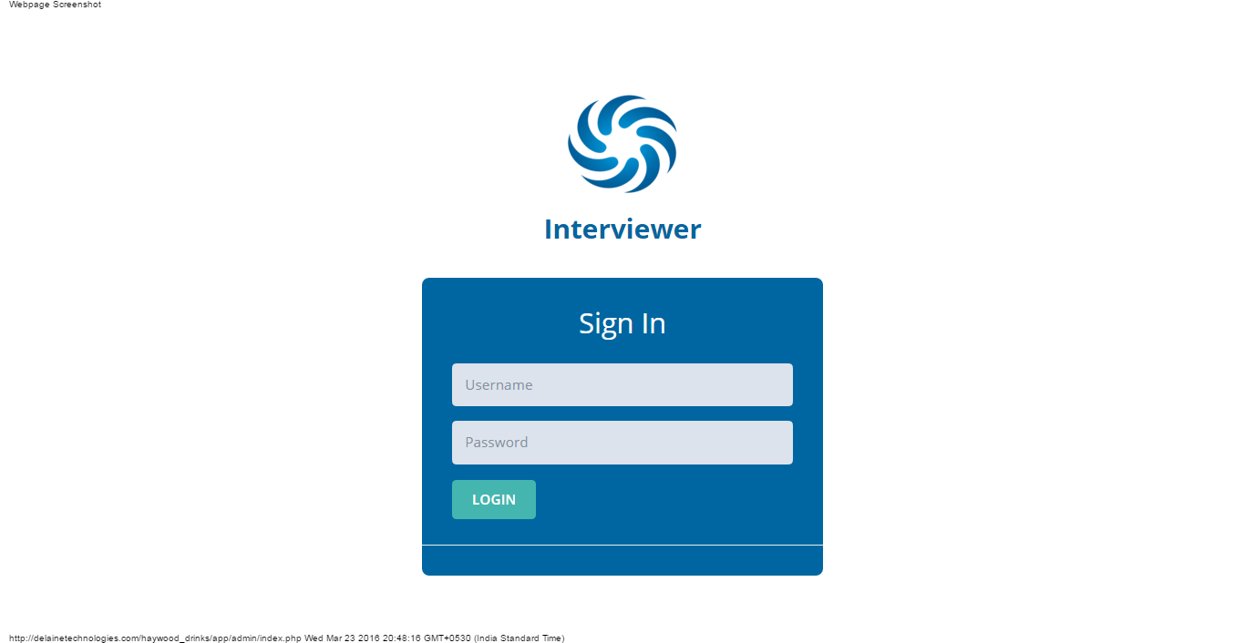

Admin Panel Login Coding: -

<!--[if IE 8]> <html lang="en" class="ie8 no-js"> <![endif]-->

<!--[if IE 9]> <html lang="en" class="ie9 no-js"> <![endif]-->

<!--[if !IE]><!-->

<html lang="en">

<!--<![endif]-->

<!-- BEGIN HEAD -->

<head>

<meta charset="utf-8"/>

<title>Interviewer</title>

<meta http-equiv="X-UA-Compatible" content="IE=edge">

<meta content="width=device-width, initial-scale=1.0" name="viewport"/>

<meta http-equiv="Content-type" content="text/html; charset=utf-8">

<meta content="" name="description"/>

<meta content="" name="author"/>

<!-- BEGIN GLOBAL MANDATORY STYLES -->

<link href="http://fonts.googleapis.com/css?family=Open+Sans:400,300,600,700&subset=all" rel="stylesheet" type="text/css"/>

<link href="assets/global/plugins/font-awesome/css/font-awesome.min.css" rel="stylesheet" type="text/css"/>

<link href="assets/global/plugins/simple-line-icons/simple-line-icons.min.css" rel="stylesheet" type="text/css"/>

<link href="assets/global/plugins/bootstrap/css/bootstrap.min.css" rel="stylesheet" type="text/css"/>

<link href="assets/global/plugins/uniform/css/uniform.default.css" rel="stylesheet" type="text/css"/>

<!-- END GLOBAL MANDATORY STYLES -->

<!-- BEGIN PAGE LEVEL STYLES -->

<link href="assets/admin/pages/css/login.css" rel="stylesheet" type="text/css"/>

<!-- END PAGE LEVEL SCRIPTS -->

<!-- BEGIN THEME STYLES -->

<link href="assets/global/css/components-rounded.css" id="style_components" rel="stylesheet" type="text/css"/>

<link href="assets/global/css/plugins.css" rel="stylesheet" type="text/css"/>

<link href="assets/admin/layout/css/layout.css" rel="stylesheet" type="text/css"/>

<link href="assets/admin/layout/css/themes/default.css" rel="stylesheet" type="text/css" id="style_color"/>

<link href="assets/admin/layout/css/custom.css" rel="stylesheet" type="text/css"/>

<!-- END THEME STYLES -->

<link rel="shortcut icon" href="favicon.ico"/>

</head>

<!-- END HEAD -->

<!-- BEGIN BODY -->

<body class="login">

<!-- BEGIN SIDEBAR TOGGLER BUTTON -->

<div class="menu-toggler sidebar-toggler">

</div>

<!-- END SIDEBAR TOGGLER BUTTON -->

<!-- BEGIN LOGO -->

<div class="logo">

<img height="100px" width="140px" src="img/logo.png" alt=""/>

<h2 align="center" style="color: #0066A1; margin-bottom: -20px;"><strong>Interviewer</strong></h2>

</div>

<!-- END LOGO -->

<!-- BEGIN LOGIN -->

<div class="content">

<!-- BEGIN LOGIN FORM -->

<form class="login-form" action="login.php" method="post">

<h3 class="form-title" style="color: #ffffff;">Sign In</h3>

<div class="alert alert-danger display-hide">

<button class="close" data-close="alert"></button>

<span>

Enter username and password. </span>

</div>

<div class="form-group">

<!--ie8, ie9 does not support html5 placeholder, so we just show field title for that-->

<label class="control-label visible-ie8 visible-ie9">Username</label>

<input class="form-control form-control-solid placeholder-no-fix" type="text" autocomplete="off" placeholder="Username" name="username"/>

</div>

<div class="form-group">

<label class="control-label visible-ie8 visible-ie9">Password</label>

<input class="form-control form-control-solid placeholder-no-fix" type="password" autocomplete="off" placeholder="Password" name="password"/>

</div>

<div class="form-actions">

<button type="submit" class="btn btn-success uppercase">Login</button>

<label class="rememberme check">

<!--<input type="checkbox" name="remember" value="1"/>Remember </label>

<a href="javascript:;" id="forget-password" class="forget-password">Forgot Password?</a>-->

</div>

</form>

<!-- END LOGIN FORM -->

</div>

<!-- END LOGIN -->

<!-- BEGIN JAVASCRIPTS(Load javascripts at bottom, this will reduce page load time) -->

<!-- BEGIN CORE PLUGINS -->

<!--[if lt IE 9]>

<script src="../../assets/global/plugins/respond.min.js"></script>

<script src="../../assets/global/plugins/excanvas.min.js"></script>

<![endif]-->

<script src="../../assets/global/plugins/jquery.min.js" type="text/javascript"></script>

<script src="../../assets/global/plugins/jquery-migrate.min.js" type="text/javascript"></script>

<script src="../../assets/global/plugins/bootstrap/js/bootstrap.min.js" type="text/javascript"></script>

<script src="../../assets/global/plugins/jquery.blockui.min.js" type="text/javascript"></script>

<script src="../../assets/global/plugins/uniform/jquery.uniform.min.js" type="text/javascript"></script>

<script src="../../assets/global/plugins/jquery.cokie.min.js" type="text/javascript"></script>

<!-- END CORE PLUGINS -->

<!-- BEGIN PAGE LEVEL PLUGINS -->

<script src="../../assets/global/plugins/jquery-validation/js/jquery.validate.min.js" type="text/javascript"></script>

<!-- END PAGE LEVEL PLUGINS -->

<!-- BEGIN PAGE LEVEL SCRIPTS -->

<script src="../../assets/global/scripts/metronic.js" type="text/javascript"></script>

<script src="../../assets/admin/layout/scripts/layout.js" type="text/javascript"></script>

<script src="../../assets/admin/layout/scripts/demo.js" type="text/javascript"></script>

<script src="../../assets/admin/pages/scripts/login.js" type="text/javascript"></script>

<!-- END PAGE LEVEL SCRIPTS -->

<script>

jQuery**(**document**)**.ready**(function() {**

Metronic.init**()**; // init metronic core components

Layout.init**()**; // init current layout

Login.init**()**;

Demo.init**()**;

**})**;

</script>

<!-- END JAVASCRIPTS -->

</body>

<!-- END BODY -->

</html>

**Admin Dashboard Page**



Admin Dashboard Page :-

**<?php**

session_start();

$username=$_SESSION['username'];

if($username=="")

{

header('location: index.php');

}

else

{

**?>**

<!--

Template Name: Metronic - Responsive Admin Dashboard Template build with Twitter Bootstrap 3.3.4

Version: 4.0.1

Author: KeenThemes

Website: http://www.keenthemes.com/

Contact: support@keenthemes.com

Follow: www.twitter.com/keenthemes

Like: www.facebook.com/keenthemes

Purchase: http://themeforest.net/item/metronic-responsive-admin-dashboard-template/4021469?ref=keenthemes

License: You must have a valid license purchased only from themeforest(the above link) in order to legally use the theme for your project.

-->

<!--[if IE 8]> <html lang="en" class="ie8 no-js"> <![endif]-->

<!--[if IE 9]> <html lang="en" class="ie9 no-js"> <![endif]-->

<!--[if !IE]><!-->

<html lang="en" class="no-js">

<!--<![endif]-->

<!-- BEGIN HEAD -->

<head>

<meta charset="utf-8">

<title>Interviewer</title>

<meta http-equiv="X-UA-Compatible" content="IE=edge">

<meta content="width=device-width, initial-scale=1" name="viewport">

<meta content="" name="description">

<meta content="" name="author">

<!-- BEGIN GLOBAL MANDATORY STYLES -->

<link href="http://fonts.googleapis.com/css?family=Open+Sans:400,300,600,700&subset=all" rel="stylesheet" type="text/css">

<link href="assets/global/plugins/font-awesome/css/font-awesome.min.css" rel="stylesheet" type="text/css">

<link href="assets/global/plugins/simple-line-icons/simple-line-icons.min.css" rel="stylesheet" type="text/css">

<link href="assets/global/plugins/bootstrap/css/bootstrap.min.css" rel="stylesheet" type="text/css">

<link href="assets/global/plugins/uniform/css/uniform.default.css" rel="stylesheet" type="text/css">

<!-- END GLOBAL MANDATORY STYLES -->

<!-- BEGIN PAGE LEVEL PLUGIN STYLES -->

<link href="assets/global/plugins/jqvmap/jqvmap/jqvmap.css" rel="stylesheet" type="text/css">

<link href="assets/global/plugins/morris/morris.css" rel="stylesheet" type="text/css">

<!-- END PAGE LEVEL PLUGIN STYLES -->

<!-- BEGIN PAGE STYLES -->

<link href="assets/admin/pages/css/tasks.css" rel="stylesheet" type="text/css"/>

<!-- END PAGE STYLES -->

<!-- BEGIN THEME STYLES -->

<!-- DOC: To use 'rounded corners' style just load 'components-rounded.css' stylesheet instead of 'components.css' in the below style tag -->

<link href="assets/global/css/components-rounded.css" id="style_components" rel="stylesheet" type="text/css">

<link href="assets/global/css/plugins.css" rel="stylesheet" type="text/css">

<link href="assets/admin/layout3/css/layout.css" rel="stylesheet" type="text/css">

<link href="assets/admin/layout3/css/themes/default.css" rel="stylesheet" type="text/css" id="style_color">

<link href="assets/admin/layout3/css/custom.css" rel="stylesheet" type="text/css">

<!-- END THEME STYLES -->

<link rel="shortcut icon" href="favicon.ico">

</head>

<!-- END HEAD -->

<!-- BEGIN BODY -->

<!-- DOC: Apply "page-header-menu-fixed" class to set the mega menu fixed -->

<!-- DOC: Apply "page-header-top-fixed" class to set the top menu fixed -->

<body>

<!-- BEGIN HEADER -->

<div class="page-header">

<!-- BEGIN HEADER TOP -->

**<?php**

include("top_header.php");

**?>**

<!-- END HEADER TOP -->

<!-- BEGIN HEADER MENU -->

**<?php**

include("header_menu.php");

**?>**

<!-- END HEADER MENU -->

</div>

<!-- END HEADER -->

<!-- BEGIN PAGE CONTAINER -->

<div class="page-container">

<!-- END PAGE HEAD -->

<!-- BEGIN PAGE CONTENT -->

<div class="page-content">

<div class="container">

<!-- BEGIN PAGE CONTENT INNER -->

**<?php**

include('conn.php');

$sql="select * from candidate";

$result=mysqli_query($conn, $sql);

$records=mysqli_num_rows($result);

**?>**

<center><img src="img/logodash.png" width="300px" height="420px"/></center>

<!-- END PAGE CONTENT INNER -->

</div>

</div>

<!-- END PAGE CONTENT -->

</div>

<!-- END PAGE CONTAINER -->

<!-- BEGIN PRE-FOOTER -->

**<?php**

include("footer.php");

**?>**

<div class="scroll-to-top">

<i class="icon-arrow-up"></i>

</div>

<!-- END FOOTER -->

<!-- BEGIN JAVASCRIPTS (Load javascripts at bottom, this will reduce page load time) -->

<!-- BEGIN CORE PLUGINS -->

<!--[if lt IE 9]>

<script src="assets/global/plugins/respond.min.js"></script>

<script src="assets/global/plugins/excanvas.min.js"></script>

<![endif]-->

<script src="assets/global/plugins/jquery.min.js" type="text/javascript"></script>

<script src="assets/global/plugins/jquery-migrate.min.js" type="text/javascript"></script>

<!-- IMPORTANT! Load jquery-ui.min.js before bootstrap.min.js to fix bootstrap tooltip conflict with jquery ui tooltip -->

<script src="assets/global/plugins/jquery-ui/jquery-ui.min.js" type="text/javascript"></script>

<script src="assets/global/plugins/bootstrap/js/bootstrap.min.js" type="text/javascript"></script>

<script src="assets/global/plugins/bootstrap-hover-dropdown/bootstrap-hover-dropdown.min.js" type="text/javascript"></script>

<script src="assets/global/plugins/jquery-slimscroll/jquery.slimscroll.min.js" type="text/javascript"></script>

<script src="assets/global/plugins/jquery.blockui.min.js" type="text/javascript"></script>

<script src="assets/global/plugins/jquery.cokie.min.js" type="text/javascript"></script>

<script src="assets/global/plugins/uniform/jquery.uniform.min.js" type="text/javascript"></script>

<!-- END CORE PLUGINS -->

<!-- BEGIN PAGE LEVEL PLUGINS -->

<script src="assets/global/plugins/jqvmap/jqvmap/jquery.vmap.js" type="text/javascript"></script>

<script src="assets/global/plugins/jqvmap/jqvmap/maps/jquery.vmap.russia.js" type="text/javascript"></script>

<script src="assets/global/plugins/jqvmap/jqvmap/maps/jquery.vmap.world.js" type="text/javascript"></script>

<script src="assets/global/plugins/jqvmap/jqvmap/maps/jquery.vmap.europe.js" type="text/javascript"></script>

<script src="assets/global/plugins/jqvmap/jqvmap/maps/jquery.vmap.germany.js" type="text/javascript"></script>

<script src="assets/global/plugins/jqvmap/jqvmap/maps/jquery.vmap.usa.js" type="text/javascript"></script>

<script src="assets/global/plugins/jqvmap/jqvmap/data/jquery.vmap.sampledata.js" type="text/javascript"></script>

<!-- IMPORTANT! fullcalendar depends on jquery-ui.min.js for drag & drop support -->

<script src="assets/global/plugins/morris/morris.min.js" type="text/javascript"></script>

<script src="assets/global/plugins/morris/raphael-min.js" type="text/javascript"></script>

<script src="assets/global/plugins/jquery.sparkline.min.js" type="text/javascript"></script>

<!-- END PAGE LEVEL PLUGINS -->

<!-- BEGIN PAGE LEVEL SCRIPTS -->

<script src="assets/global/scripts/metronic.js" type="text/javascript"></script>

<script src="assets/admin/layout3/scripts/layout.js" type="text/javascript"></script>

<script src="assets/admin/layout2/scripts/quick-sidebar.js" type="text/javascript"></script>

<script src="assets/admin/layout3/scripts/demo.js" type="text/javascript"></script>

<script src="assets/admin/pages/scripts/index3.js" type="text/javascript"></script>

<script src="assets/admin/pages/scripts/tasks.js" type="text/javascript"></script>

<!-- END PAGE LEVEL SCRIPTS -->

<script>

jQuery**(**document**)**.ready**(function() {**

Metronic.init**()**; // init metronic core componets

Layout.init**()**; // init layout

Demo.init**()**; // init demo(theme settings page)

QuickSidebar.init**()**; // init quick sidebar

Index.init**()**; // init index page

Tasks.initDashboardWidget**()**; // init tash dashboard widget

**})**;

</script>

<!-- END JAVASCRIPTS -->

</body>

<!-- END BODY -->

</html>

**<?php**

}

**?>**

**View Candidate Records**

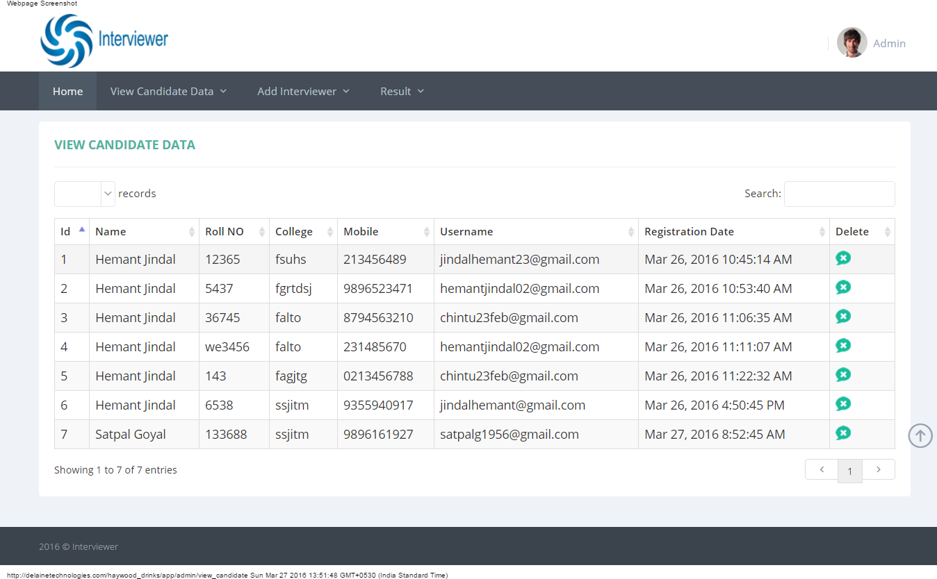

View Candidate Page Coding :-

**<?php**

session_start();

$username=$_SESSION['username'];

if($username=="")

{

header('location: index.php');

}

else

{

**?>**

<!--[if IE 8]> <html lang="en" class="ie8 no-js"> <![endif]-->

<!--[if IE 9]> <html lang="en" class="ie9 no-js"> <![endif]-->

<!--[if !IE]><!-->

<html lang="en">

<!--<![endif]-->

<!-- BEGIN HEAD -->

<head>

<meta charset="utf-8"/>

<title>Interviewer</title>

<meta http-equiv="X-UA-Compatible" content="IE=edge">

<meta content="width=device-width, initial-scale=1.0" name="viewport"/>

<meta http-equiv="Content-type" content="text/html; charset=utf-8">

<meta content="" name="description"/>

<meta content="" name="author"/>

<!-- BEGIN GLOBAL MANDATORY STYLES -->

<link href="http://fonts.googleapis.com/css?family=Open+Sans:400,300,600,700&subset=all" rel="stylesheet" type="text/css">

<link href="assets/global/plugins/font-awesome/css/font-awesome.min.css" rel="stylesheet" type="text/css">

<link href="assets/global/plugins/simple-line-icons/simple-line-icons.min.css" rel="stylesheet" type="text/css">

<link href="assets/global/plugins/bootstrap/css/bootstrap.min.css" rel="stylesheet" type="text/css">

<link href="assets/global/plugins/uniform/css/uniform.default.css" rel="stylesheet" type="text/css">

<!-- END GLOBAL MANDATORY STYLES -->

<!-- BEGIN PAGE LEVEL STYLES -->

<link rel="stylesheet" type="text/css" href="assets/global/plugins/select2/select2.css"/>

<link rel="stylesheet" type="text/css" href="assets/global/plugins/datatables/plugins/bootstrap/dataTables.bootstrap.css"/>

<!-- END PAGE LEVEL STYLES -->

<!-- BEGIN THEME STYLES -->

<link href="assets/global/css/components-rounded.css" id="style_components" rel="stylesheet" type="text/css">

<link href="assets/global/css/plugins.css" rel="stylesheet" type="text/css">

<link href="assets/admin/layout3/css/layout.css" rel="stylesheet" type="text/css">

<link href="assets/admin/layout3/css/themes/default.css" rel="stylesheet" type="text/css" id="style_color">

<link href="assets/admin/layout3/css/custom.css" rel="stylesheet" type="text/css">

<!-- END THEME STYLES -->

<link rel="shortcut icon" href="favicon.ico"/>

</head>

<!-- END HEAD -->

<!-- BEGIN BODY -->

<!-- DOC: Apply "page-header-menu-fixed" class to set the mega menu fixed -->

<!-- DOC: Apply "page-header-top-fixed" class to set the top menu fixed -->

<body>

<!-- BEGIN HEADER -->

<div class="page-header">

<!-- BEGIN HEADER TOP -->

**<?php**

include("top_header.php");

**?>**

<!-- END HEADER TOP -->

<!-- BEGIN HEADER MENU -->

**<?php**

include("header_menu.php");

**?>**

<!-- END HEADER MENU -->

</div>

<!-- END HEADER -->

<!-- BEGIN PAGE CONTAINER -->

<div class="page-container">

<!-- BEGIN PAGE CONTENT -->

<div class="page-content">

<div class="container">

<!-- BEGIN SAMPLE PORTLET CONFIGURATION MODAL FORM-->

<div class="modal fade" id="portlet-config" tabindex="-1" role="dialog" aria-labelledby="myModalLabel" aria-hidden="true">

<div class="modal-dialog">

<div class="modal-content">

<div class="modal-header">

<button type="button" class="close" data-dismiss="modal" aria-hidden="true"></button>

<h4 class="modal-title">Modal title</h4>

</div>

<div class="modal-body">

Widget settings form goes here

</div>

<div class="modal-footer">

<button type="button" class="btn blue">Save changes</button>

<button type="button" class="btn default" data-dismiss="modal">Close</button>

</div>

</div>

<!-- /.modal-content -->

</div>

<!-- /.modal-dialog -->

</div>

<!-- /.modal -->

<!-- END SAMPLE PORTLET CONFIGURATION MODAL FORM-->

<!-- BEGIN PAGE BREADCRUMB -->

<!--<ul class="page-breadcrumb breadcrumb">

<li>

<a href="index.php">Home</a><i class="fa fa-circle"></i>

</li>

<li class="active">

<?php echo $type; ?>

</li>

</ul>-->

<!-- END PAGE BREADCRUMB -->

<!-- BEGIN PAGE CONTENT INNER -->

<div class="row">

<div class="col-md-12">

<!-- BEGIN EXAMPLE TABLE PORTLET-->

<div class="portlet light">

<div class="portlet-title">

<div class="caption">

<span class="caption-subject font-green-sharp bold uppercase">View Candidate Data</span>

</div>

<!--<div class="tools">

<a href="javascript:;" class="collapse">

</a>

<a href="#portlet-config" data-toggle="modal" class="config">

</a>

<a href="javascript:;" class="reload">

</a>

<a href="javascript:;" class="remove">

</a>

</div>-->

</div>

<div class="portlet-body">

<!--<div class="table-toolbar">

<div class="row">

<div class="col-md-6">

<div class="btn-group">

<button id="sample_editable_1_new" class="btn green">

Add New <i class="fa fa-plus"></i>

</button>

</div>

</div>

<div class="col-md-6">

<div class="btn-group pull-right">

<button class="btn dropdown-toggle" data-toggle="dropdown">Tools <i class="fa fa-angle-down"></i>

</button>

<ul class="dropdown-menu pull-right">

<li>

<a href="javascript:;">

Print </a>

</li>

<li>

<a href="javascript:;">

Save as PDF </a>

</li>

<li>

<a href="javascript:;">

Export to Excel </a>

</li>

</ul>

</div>

</div>

</div>-->

</div>

<table class="table table-striped table-hover table-bordered" id="sample_editable_1">

<thead>

<tr>

<th>

Id

</th>

<th>

Name

</th>

<th>

Roll NO

</th>

<th>

College

</th>

<th>

Mobile

</th>

<th>

Username

</th>

<th>

Registration Date

</th>

<th>

Delete

</th>

</tr>

</thead>

<tbody>

**<?php**

include('conn.php');

$i=1;

$sql="select * from candidate order by id asc";

$result=mysqli_query($conn, $sql);

while($row=mysqli_fetch_array($result))

{

**?>**

<tr>

<td>

**<?php** echo $i++;**?>**

</td>

<td>

**<?php** echo $row['name'];**?>**

</td>

<td>

**<?php** echo $row['roll_no'];**?>**

</td>

<td>

**<?php** echo $row['college'];**?>**

</td>

<td>

**<?php** echo $row['mobile'];**?>**

</td>

<td>

**<?php** echo $row['email'];**?>**

</td>

<td>

**<?php** echo $row['reg_date'];**?>**

</td>

<!--<td>

<?php echo $row['int1'];?>

</td>

<td>

<?php echo $row['int2'];?>

</td>

<td>

<?php echo $row['int3'];?>

</td>

<td>

<?php echo $row['average'];?>

</td>

<td>

<?php echo $row['termsmsg'];?>

</td>

<td>

<?php echo $row['namepcode'];?>

</td>-->

<td>

<a href="delete_candidate?id=**<?php** echo $row['id']; **?>**">

<img src="img/delete.png" /></a>

</td>

<!--<td>

<a href="reminders.php?id=<?php echo $row['id'];?>">Reminders</a>

</td>-->

</tr>

**<?php**

}

**?>**

</tbody>

</table>

</div>

</div>

<!-- END EXAMPLE TABLE PORTLET-->

</div>

</div>

<!-- END PAGE CONTENT -->

</div>

</div>

<!-- END PAGE CONTENT -->

</div>

<!-- END PAGE CONTAINER -->

<!-- BEGIN PRE-FOOTER -->

**<?php**

include("footer.php");

**?>**

<div class="scroll-to-top">

<i class="icon-arrow-up"></i>

</div>

<!-- END FOOTER -->

<!-- BEGIN JAVASCRIPTS(Load javascripts at bottom, this will reduce page load time) -->

<!-- BEGIN CORE PLUGINS -->

<!--[if lt IE 9]>

<script src="assets/global/plugins/respond.min.js"></script>

<script src="assets/global/plugins/excanvas.min.js"></script>

<![endif]-->

<script src="assets/global/plugins/jquery.min.js" type="text/javascript"></script>

<script src="assets/global/plugins/jquery-migrate.min.js" type="text/javascript"></script>

<!-- IMPORTANT! Load jquery-ui.min.js before bootstrap.min.js to fix bootstrap tooltip conflict with jquery ui tooltip -->

<script src="assets/global/plugins/jquery-ui/jquery-ui.min.js" type="text/javascript"></script>

<script src="assets/global/plugins/bootstrap/js/bootstrap.min.js" type="text/javascript"></script>

<script src="assets/global/plugins/bootstrap-hover-dropdown/bootstrap-hover-dropdown.min.js" type="text/javascript"></script>

<script src="assets/global/plugins/jquery-slimscroll/jquery.slimscroll.min.js" type="text/javascript"></script>

<script src="assets/global/plugins/jquery.blockui.min.js" type="text/javascript"></script>

<script src="assets/global/plugins/jquery.cokie.min.js" type="text/javascript"></script>

<script src="assets/global/plugins/uniform/jquery.uniform.min.js" type="text/javascript"></script>

<!-- END CORE PLUGINS -->

<!-- BEGIN PAGE LEVEL PLUGINS -->

<script type="text/javascript" src="assets/global/plugins/select2/select2.min.js"></script>

<script type="text/javascript" src="assets/global/plugins/datatables/media/js/jquery.dataTables.min.js"></script>

<script type="text/javascript" src="assets/global/plugins/datatables/plugins/bootstrap/dataTables.bootstrap.js"></script>

<!-- END PAGE LEVEL PLUGINS -->

<!-- BEGIN PAGE LEVEL SCRIPTS -->

<script src="assets/global/scripts/metronic.js" type="text/javascript"></script>

<script src="assets/admin/layout3/scripts/layout.js" type="text/javascript"></script>

<script src="assets/admin/layout3/scripts/demo.js" type="text/javascript"></script>

<script src="assets/admin/pages/scripts/table-editable.js"></script>

<script>

jQuery**(**document**)**.ready**(function() {**

Metronic.init**()**; // init metronic core components

Layout.init**()**; // init current layout

Demo.init**()**; // init demo features

TableEditable.init**()**;

**})**;

</script>

</body>

<!-- END BODY -->

</html>

**<?php** } **?>**

**Add/View Interviewer**

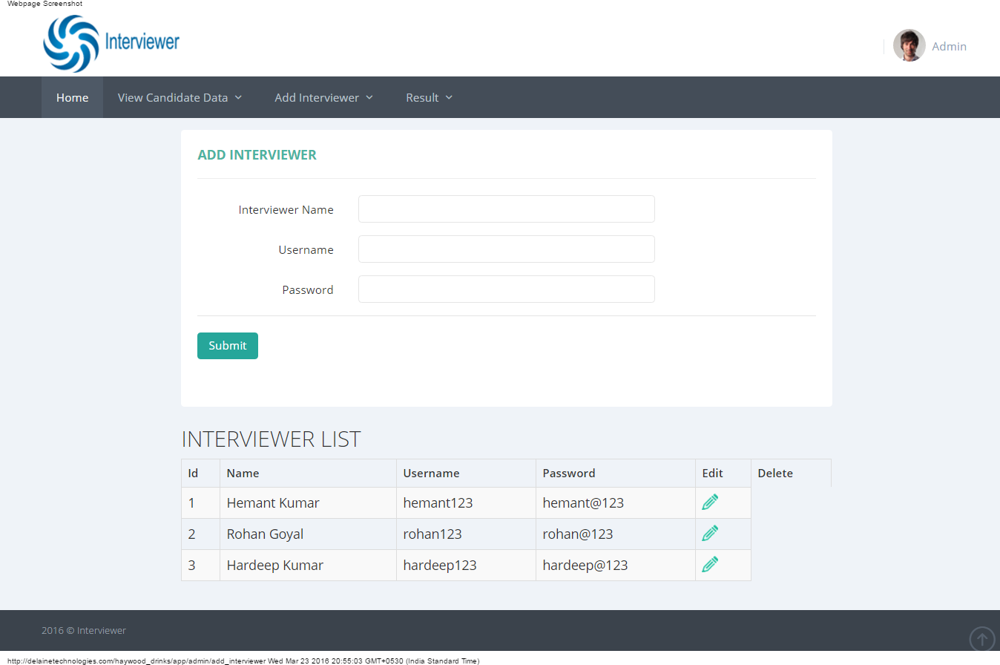

Add and View Interviewer :-

**<?php**

session_start();

$username=$_SESSION['username'];

if($username=="")

{

header('location: index.php');

}

else

{

**?>**

<!--[if IE 8]> <html lang="en" class="ie8 no-js"> <![endif]-->

<!--[if IE 9]> <html lang="en" class="ie9 no-js"> <![endif]-->

<!--[if !IE]><!-->

<html lang="en">

<!--<![endif]-->

<!-- BEGIN HEAD -->

<head>

<meta charset="utf-8"/>

<title>Interviewer</title>

<meta http-equiv="X-UA-Compatible" content="IE=edge">

<meta content="width=device-width, initial-scale=1.0" name="viewport"/>

<meta http-equiv="Content-type" content="text/html; charset=utf-8">

<meta content="" name="description"/>

<meta content="" name="author"/>

<!-- BEGIN GLOBAL MANDATORY STYLES -->

<link href="http://fonts.googleapis.com/css?family=Open+Sans:400,300,600,700&subset=all" rel="stylesheet" type="text/css">

<link href="assets/global/plugins/font-awesome/css/font-awesome.min.css" rel="stylesheet" type="text/css">

<link href="assets/global/plugins/simple-line-icons/simple-line-icons.min.css" rel="stylesheet" type="text/css">

<link href="assets/global/plugins/bootstrap/css/bootstrap.min.css" rel="stylesheet" type="text/css">

<link href="assets/global/plugins/uniform/css/uniform.default.css" rel="stylesheet" type="text/css">

<!-- END GLOBAL MANDATORY STYLES -->

<!-- BEGIN PAGE LEVEL STYLES -->

<link rel="stylesheet" type="text/css" href="assets/global/plugins/select2/select2.css"/>

<link rel="stylesheet" type="text/css" href="assets/global/plugins/datatables/plugins/bootstrap/dataTables.bootstrap.css"/>

<!-- END PAGE LEVEL STYLES -->

<!-- BEGIN THEME STYLES -->

<link href="assets/global/css/components-rounded.css" id="style_components" rel="stylesheet" type="text/css">

<link href="assets/global/css/plugins.css" rel="stylesheet" type="text/css">

<link href="assets/admin/layout3/css/layout.css" rel="stylesheet" type="text/css">

<link href="assets/admin/layout3/css/themes/default.css" rel="stylesheet" type="text/css" id="style_color">

<link href="assets/admin/layout3/css/custom.css" rel="stylesheet" type="text/css">

<!-- END THEME STYLES -->

<link rel="shortcut icon" href="favicon.ico"/>

</head>

<!-- END HEAD -->

<!-- BEGIN BODY -->

<!-- DOC: Apply "page-header-menu-fixed" class to set the mega menu fixed -->

<!-- DOC: Apply "page-header-top-fixed" class to set the top menu fixed -->

<body>

<!-- BEGIN HEADER -->

<div class="page-header">

<!-- BEGIN HEADER TOP -->

**<?php**

include("top_header.php");

**?>**

<!-- END HEADER TOP -->

<!-- BEGIN HEADER MENU -->

**<?php**

include("header_menu.php");

**?>**

<!-- END HEADER MENU -->

</div>

<!-- END HEADER -->

<!-- BEGIN PAGE CONTAINER -->

<div class="page-container">

<!-- BEGIN PAGE CONTENT -->

<div class="page-content">

<div class="container">

<!-- BEGIN SAMPLE PORTLET CONFIGURATION MODAL FORM-->

<div class="modal fade" id="portlet-config" tabindex="-1" role="dialog" aria-labelledby="myModalLabel" aria-hidden="true">

<div class="modal-dialog">

<div class="modal-content">

<div class="modal-header">

<button type="button" class="close" data-dismiss="modal" aria-hidden="true"></button>

<h4 class="modal-title">Modal title</h4>

</div>

<div class="modal-body">

Widget settings form goes here

</div>

<div class="modal-footer">

<button type="button" class="btn blue">Save changes</button>

<button type="button" class="btn default" data-dismiss="modal">Close</button>

</div>

</div>

<!-- /.modal-content -->

</div>

<!-- /.modal-dialog -->

</div>

<!-- /.modal -->

<!-- END SAMPLE PORTLET CONFIGURATION MODAL FORM-->

<!-- BEGIN PAGE BREADCRUMB -->

<!--<ul class="page-breadcrumb breadcrumb">

<li>

<a href="index.php">Home</a><i class="fa fa-circle"></i>

</li>

<li class="active">

<?php echo $type; ?>

</li>

</ul>-->

<!-- END PAGE BREADCRUMB -->

<!-- BEGIN PAGE CONTENT INNER -->

<div class="row">

<div class="col-md-12">

<!-- BEGIN EXAMPLE TABLE PORTLET-->

<div class="portlet light">

<div class="portlet-title">

<div class="caption">

<span class="caption-subject font-green-sharp bold uppercase">View Customer Data</span>

</div>

<!--<div class="tools">

<a href="javascript:;" class="collapse">

</a>

<a href="#portlet-config" data-toggle="modal" class="config">

</a>

<a href="javascript:;" class="reload">

</a>

<a href="javascript:;" class="remove">

</a>

</div>-->

</div>

<div class="portlet-body">

<!--<div class="table-toolbar">

<div class="row">

<div class="col-md-6">

<div class="btn-group">

<button id="sample_editable_1_new" class="btn green">

Add New <i class="fa fa-plus"></i>

</button>

</div>

</div>

<div class="col-md-6">

<div class="btn-group pull-right">

<button class="btn dropdown-toggle" data-toggle="dropdown">Tools <i class="fa fa-angle-down"></i>

</button>

<ul class="dropdown-menu pull-right">

<li>

<a href="javascript:;">

Print </a>

</li>

<li>

<a href="javascript:;">

Save as PDF </a>

</li>

<li>

<a href="javascript:;">

Export to Excel </a>

</li>

</ul>

</div>

</div>

</div>-->

</div>

<table class="table table-striped table-hover table-bordered" id="sample_editable_1">

<thead>

<tr>

<th>

Id

</th>

<th>

Customer Code

</th>

<th>

User Name

</th>

<th>

Password

</th>

<th>

Address

</th>

<th>

Town

</th>

<!--<th>

Country

</th>-->

<th>

Postcode

</th>

<th>

Phone

</th>

<th>

Mobile

</th>

<th>

Contact Name

</th>

<th>

Email

</th>

<th>

Role

</th>

<!--<th>

Termsmsg

</th>

<th>

Name Post Code

</th>-->

<th>

Edit

</th>

<th>

Delete

</th>

</tr>

</thead>

<tbody>

**<?php**

include('conn.php');

$sql="select * from login";

$result=mysqli_query($conn, $sql);

while($row=mysqli_fetch_array($result))

{

**?>**

<tr>

<td>

**<?php** echo $row['id'];**?>**

</td>

<td>

**<?php** echo $row['customercode'];**?>**

</td>

<td>

**<?php** echo $row['username'];**?>**

</td>

<td>

**<?php** echo $row['password'];**?>**

</td>

<td>

**<?php** echo $row['address'];**?>**

</td>

<td>

**<?php** echo $row['town'];**?>**

</td>

<!--<td>

<?php echo $row['country'];?>

</td>-->

<td>

**<?php** echo $row['postcode'];**?>**

</td>

<td>

**<?php** echo $row['phone'];**?>**

</td>

<td>

**<?php** echo $row['mobile'];**?>**

</td>

<td>

**<?php** echo $row['contactname'];**?>**

</td>

<td>

**<?php** echo $row['email'];**?>**

</td>

<td>

**<?php** echo $row['role'];**?>**

</td>

<!--<td>

<?php echo $row['termsmsg'];?>

</td>

<td>

<?php echo $row['namepcode'];?>

</td>-->

<td>

<a href="edit_customer.php?id=**<?php** echo $row['id']; **?>**">

<img src="img/edit.png" /></a>

</td>

<td>

<a href="delete_customer.php?id=**<?php** echo $row['id']; **?>**">

<img src="img/delete.png" /></a>

</td>

<!--<td>

<a href="reminders.php?id=<?php echo $row['id'];?>">Reminders</a>

</td>-->

</tr>

**<?php**

}

**?>**

</tbody>

</table>

</div>

</div>

<!-- END EXAMPLE TABLE PORTLET-->

</div>

</div>

<!-- END PAGE CONTENT -->

</div>

</div>

<!-- END PAGE CONTENT -->

</div>

<!-- END PAGE CONTAINER -->

<!-- BEGIN PRE-FOOTER -->

**<?php**

include("footer.php");

**?>**

<div class="scroll-to-top">

<i class="icon-arrow-up"></i>

</div>

<!-- END FOOTER -->

<!-- BEGIN JAVASCRIPTS(Load javascripts at bottom, this will reduce page load time) -->

<!-- BEGIN CORE PLUGINS -->

<!--[if lt IE 9]>

<script src="assets/global/plugins/respond.min.js"></script>

<script src="assets/global/plugins/excanvas.min.js"></script>

<![endif]-->

<script src="assets/global/plugins/jquery.min.js" type="text/javascript"></script>

<script src="assets/global/plugins/jquery-migrate.min.js" type="text/javascript"></script>

<!-- IMPORTANT! Load jquery-ui.min.js before bootstrap.min.js to fix bootstrap tooltip conflict with jquery ui tooltip -->

<script src="assets/global/plugins/jquery-ui/jquery-ui.min.js" type="text/javascript"></script>

<script src="assets/global/plugins/bootstrap/js/bootstrap.min.js" type="text/javascript"></script>

<script src="assets/global/plugins/bootstrap-hover-dropdown/bootstrap-hover-dropdown.min.js" type="text/javascript"></script>

<script src="assets/global/plugins/jquery-slimscroll/jquery.slimscroll.min.js" type="text/javascript"></script>

<script src="assets/global/plugins/jquery.blockui.min.js" type="text/javascript"></script>

<script src="assets/global/plugins/jquery.cokie.min.js" type="text/javascript"></script>

<script src="assets/global/plugins/uniform/jquery.uniform.min.js" type="text/javascript"></script>

<!-- END CORE PLUGINS -->

<!-- BEGIN PAGE LEVEL PLUGINS -->

<script type="text/javascript" src="assets/global/plugins/select2/select2.min.js"></script>

<script type="text/javascript" src="assets/global/plugins/datatables/media/js/jquery.dataTables.min.js"></script>

<script type="text/javascript" src="assets/global/plugins/datatables/plugins/bootstrap/dataTables.bootstrap.js"></script>

<!-- END PAGE LEVEL PLUGINS -->

<!-- BEGIN PAGE LEVEL SCRIPTS -->

<script src="assets/global/scripts/metronic.js" type="text/javascript"></script>

<script src="assets/admin/layout3/scripts/layout.js" type="text/javascript"></script>

<script src="assets/admin/layout3/scripts/demo.js" type="text/javascript"></script>

<script src="assets/admin/pages/scripts/table-editable.js"></script>

<script>

jQuery**(**document**)**.ready**(function() {**

Metronic.init**()**; // init metronic core components

Layout.init**()**; // init current layout

Demo.init**()**; // init demo features

TableEditable.init**()**;

**})**;

</script>

</body>

<!-- END BODY -->

</html>

**<?php** } **?>**

**Selected Candidate Page**

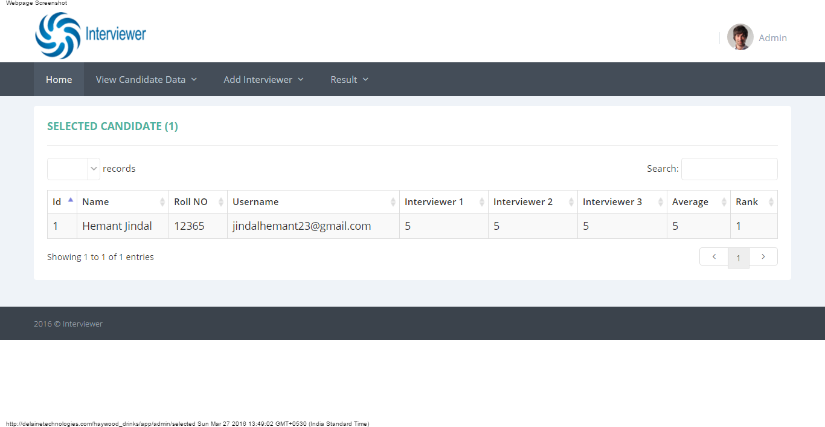

Selected Candidate Page Coding :-

**<?php**

session_start();

$username=$_SESSION['username'];

if($username=="")

{

header('location: index.php');

}

else

{

**?>**

<!--[if IE 8]> <html lang="en" class="ie8 no-js"> <![endif]-->

<!--[if IE 9]> <html lang="en" class="ie9 no-js"> <![endif]-->

<!--[if !IE]><!-->

<html lang="en">

<!--<![endif]-->

<!-- BEGIN HEAD -->

<head>

<meta charset="utf-8"/>

<title>Interviewer</title>

<meta http-equiv="X-UA-Compatible" content="IE=edge">

<meta content="width=device-width, initial-scale=1.0" name="viewport"/>

<meta http-equiv="Content-type" content="text/html; charset=utf-8">

<meta content="" name="description"/>

<meta content="" name="author"/>

<!-- BEGIN GLOBAL MANDATORY STYLES -->

<link href="http://fonts.googleapis.com/css?family=Open+Sans:400,300,600,700&subset=all" rel="stylesheet" type="text/css">

<link href="assets/global/plugins/font-awesome/css/font-awesome.min.css" rel="stylesheet" type="text/css">

<link href="assets/global/plugins/simple-line-icons/simple-line-icons.min.css" rel="stylesheet" type="text/css">

<link href="assets/global/plugins/bootstrap/css/bootstrap.min.css" rel="stylesheet" type="text/css">

<link href="assets/global/plugins/uniform/css/uniform.default.css" rel="stylesheet" type="text/css">

<!-- END GLOBAL MANDATORY STYLES -->

<!-- BEGIN PAGE LEVEL STYLES -->

<link rel="stylesheet" type="text/css" href="assets/global/plugins/select2/select2.css"/>

<link rel="stylesheet" type="text/css" href="assets/global/plugins/datatables/plugins/bootstrap/dataTables.bootstrap.css"/>

<!-- END PAGE LEVEL STYLES -->

<!-- BEGIN THEME STYLES -->

<link href="assets/global/css/components-rounded.css" id="style_components" rel="stylesheet" type="text/css">

<link href="assets/global/css/plugins.css" rel="stylesheet" type="text/css">

<link href="assets/admin/layout3/css/layout.css" rel="stylesheet" type="text/css">

<link href="assets/admin/layout3/css/themes/default.css" rel="stylesheet" type="text/css" id="style_color">

<link href="assets/admin/layout3/css/custom.css" rel="stylesheet" type="text/css">

<!-- END THEME STYLES -->

<link rel="shortcut icon" href="favicon.ico"/>

</head>

<!-- END HEAD -->

<!-- BEGIN BODY -->

<!-- DOC: Apply "page-header-menu-fixed" class to set the mega menu fixed -->

<!-- DOC: Apply "page-header-top-fixed" class to set the top menu fixed -->

<body>

<!-- BEGIN HEADER -->

<div class="page-header">

<!-- BEGIN HEADER TOP -->

**<?php**

include("top_header.php");

**?>**

<!-- END HEADER TOP -->

<!-- BEGIN HEADER MENU -->

**<?php**

include("header_menu.php");

**?>**

<!-- END HEADER MENU -->

</div>

<!-- END HEADER -->

<!-- BEGIN PAGE CONTAINER -->

<div class="page-container">

<!-- BEGIN PAGE CONTENT -->

<div class="page-content">

<div class="container">

<!-- BEGIN SAMPLE PORTLET CONFIGURATION MODAL FORM-->

<div class="modal fade" id="portlet-config" tabindex="-1" role="dialog" aria-labelledby="myModalLabel" aria-hidden="true">

<div class="modal-dialog">

<div class="modal-content">

<div class="modal-header">

<button type="button" class="close" data-dismiss="modal" aria-hidden="true"></button>

<h4 class="modal-title">Modal title</h4>

</div>

<div class="modal-body">

Widget settings form goes here

</div>

<div class="modal-footer">

<button type="button" class="btn blue">Save changes</button>

<button type="button" class="btn default" data-dismiss="modal">Close</button>

</div>

</div>

<!-- /.modal-content -->

</div>

<!-- /.modal-dialog -->

</div>

<!-- /.modal -->

<!-- END SAMPLE PORTLET CONFIGURATION MODAL FORM-->

<!-- BEGIN PAGE BREADCRUMB -->

<!--<ul class="page-breadcrumb breadcrumb">

<li>

<a href="index.php">Home</a><i class="fa fa-circle"></i>

</li>

<li class="active">

<?php echo $type; ?>

</li>

</ul>-->

<!-- END PAGE BREADCRUMB -->

<!-- BEGIN PAGE CONTENT INNER -->

<div class="row">

<div class="col-md-12">

<!-- BEGIN EXAMPLE TABLE PORTLET-->

<div class="portlet light">

<div class="portlet-title">

<div class="caption">

**<?php**

include('conn.php');

$i=1;

$sql="select * from candidate where rank>=1";

$result=mysqli_query($conn, $sql);

$records= mysqli_num_rows($result);

**?>**

<span class="caption-subject font-green-sharp bold uppercase">Selected Candidate (**<?php** echo $records; **?>**)</span>

</div>

<!--<div class="tools">

<a href="javascript:;" class="collapse">

</a>

<a href="#portlet-config" data-toggle="modal" class="config">

</a>

<a href="javascript:;" class="reload">

</a>

<a href="javascript:;" class="remove">

</a>

</div>-->

</div>

<div class="portlet-body">

<!--<div class="table-toolbar">

<div class="row">

<div class="col-md-6">

<div class="btn-group">

<button id="sample_editable_1_new" class="btn green">

Add New <i class="fa fa-plus"></i>

</button>

</div>

</div>

<div class="col-md-6">

<div class="btn-group pull-right">

<button class="btn dropdown-toggle" data-toggle="dropdown">Tools <i class="fa fa-angle-down"></i>

</button>

<ul class="dropdown-menu pull-right">

<li>

<a href="javascript:;">

Print </a>

</li>

<li>

<a href="javascript:;">

Save as PDF </a>

</li>

<li>

<a href="javascript:;">

Export to Excel </a>

</li>

</ul>

</div>

</div>

</div>-->

</div>

<table class="table table-striped table-hover table-bordered" id="sample_editable_1">

<thead>

<tr>

<th>

Id

</th>

<th>

Name

</th>

<th>

Roll NO

</th>

<th>

Username

</th>

<th>

Interviewer 1

</th>

<th>

Interviewer 2

</th>

<th>

Interviewer 3

</th>

<th>

Average

</th>

<th>

Rank

</th>

<!--<th>

Termsmsg

</th>

<th>

Name Post Code

</th>

<th>

Delete

</th>-->

</tr>

</thead>

<tbody>

**<?php**

include('conn.php');

$i=1;

$sql="select * from candidate where rank>=1";

$result=mysqli_query($conn, $sql);

while($row=mysqli_fetch_array($result))

{

**?>**

<tr>

<td>

**<?php** echo $i++;**?>**

</td>

<td>

**<?php** echo $row['name'];**?>**

</td>

<td>

**<?php** echo $row['roll_no'];**?>**

</td>

<!--<td>

<?php echo $row['college'];?>

</td>

<td>

<?php echo $row['mobile'];?>

</td>-->

<td>

**<?php** echo $row['email'];**?>**

</td>

<!--<td>

<?php echo $row['country'];?>

</td>-->

<!--<td>

<?php echo $row['password'];?>

</td>

<td>

<?php echo $row['reg_date'];?>

</td>-->

<td>

**<?php** echo $row['int1'];**?>**

</td>

<td>

**<?php** echo $row['int2'];**?>**

</td>

<td>

**<?php** echo $row['int3'];**?>**

</td>

<td>

**<?php** echo $row['average'];**?>**

</td>

<td>

**<?php** echo $row['rank'];**?>**

</td>

<!--<td>

<?php echo $row['termsmsg'];?>

</td>

<td>

<?php echo $row['namepcode'];?>

</td>-->

<!--<td>

<a href="delete_selected?id=<?php echo $row['id']; ?>">

<img src="img/delete.png" /></a>

</td>-->

<!--<td>

<a href="reminders.php?id=<?php echo $row['id'];?>">Reminders</a>

</td>-->

</tr>

**<?php**

}

**?>**

</tbody>

</table>

</div>

</div>

<!-- END EXAMPLE TABLE PORTLET-->

</div>

</div>

<!-- END PAGE CONTENT -->

</div>

</div>

<!-- END PAGE CONTENT -->

</div>

<!-- END PAGE CONTAINER -->

<!-- BEGIN PRE-FOOTER -->

**<?php**

include("footer.php");

**?>**

<div class="scroll-to-top">

<i class="icon-arrow-up"></i>

</div>

<!-- END FOOTER -->

<!-- BEGIN JAVASCRIPTS(Load javascripts at bottom, this will reduce page load time) -->

<!-- BEGIN CORE PLUGINS -->

<!--[if lt IE 9]>

<script src="assets/global/plugins/respond.min.js"></script>

<script src="assets/global/plugins/excanvas.min.js"></script>

<![endif]-->

<script src="assets/global/plugins/jquery.min.js" type="text/javascript"></script>

<script src="assets/global/plugins/jquery-migrate.min.js" type="text/javascript"></script>

<!-- IMPORTANT! Load jquery-ui.min.js before bootstrap.min.js to fix bootstrap tooltip conflict with jquery ui tooltip -->

<script src="assets/global/plugins/jquery-ui/jquery-ui.min.js" type="text/javascript"></script>

<script src="assets/global/plugins/bootstrap/js/bootstrap.min.js" type="text/javascript"></script>

<script src="assets/global/plugins/bootstrap-hover-dropdown/bootstrap-hover-dropdown.min.js" type="text/javascript"></script>

<script src="assets/global/plugins/jquery-slimscroll/jquery.slimscroll.min.js" type="text/javascript"></script>

<script src="assets/global/plugins/jquery.blockui.min.js" type="text/javascript"></script>

<script src="assets/global/plugins/jquery.cokie.min.js" type="text/javascript"></script>

<script src="assets/global/plugins/uniform/jquery.uniform.min.js" type="text/javascript"></script>

<!-- END CORE PLUGINS -->

<!-- BEGIN PAGE LEVEL PLUGINS -->

<script type="text/javascript" src="assets/global/plugins/select2/select2.min.js"></script>

<script type="text/javascript" src="assets/global/plugins/datatables/media/js/jquery.dataTables.min.js"></script>

<script type="text/javascript" src="assets/global/plugins/datatables/plugins/bootstrap/dataTables.bootstrap.js"></script>

<!-- END PAGE LEVEL PLUGINS -->

<!-- BEGIN PAGE LEVEL SCRIPTS -->

<script src="assets/global/scripts/metronic.js" type="text/javascript"></script>

<script src="assets/admin/layout3/scripts/layout.js" type="text/javascript"></script>

<script src="assets/admin/layout3/scripts/demo.js" type="text/javascript"></script>

<script src="assets/admin/pages/scripts/table-editable.js"></script>

<script>

jQuery**(**document**)**.ready**(function() {**

Metronic.init**()**; // init metronic core components

Layout.init**()**; // init current layout

Demo.init**()**; // init demo features

TableEditable.init**()**;

**})**;

</script>

</body>

<!-- END BODY -->

</html>

**<?php** } **?>**

**Pending Candidates Page**

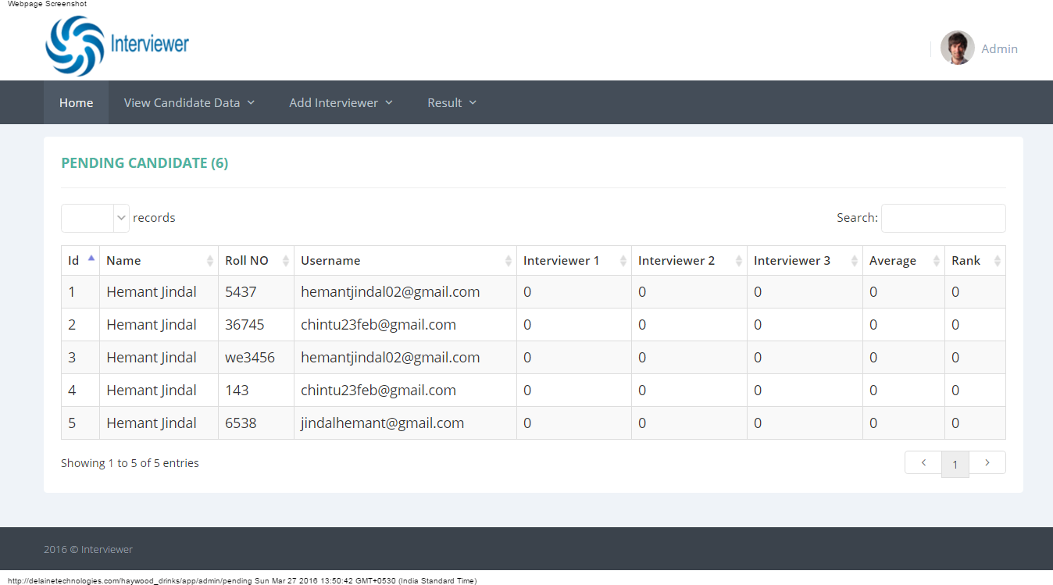

Pending Candidates Page Coding :-

**<?php**

session_start();

$username=$_SESSION['username'];

if($username=="")

{

header('location: index.php');

}

else

{

**?>**

<!--[if IE 8]> <html lang="en" class="ie8 no-js"> <![endif]-->

<!--[if IE 9]> <html lang="en" class="ie9 no-js"> <![endif]-->

<!--[if !IE]><!-->

<html lang="en">

<!--<![endif]-->

<!-- BEGIN HEAD -->

<head>

<meta charset="utf-8"/>

<title>Interviewer</title>

<meta http-equiv="X-UA-Compatible" content="IE=edge">

<meta content="width=device-width, initial-scale=1.0" name="viewport"/>

<meta http-equiv="Content-type" content="text/html; charset=utf-8">

<meta content="" name="description"/>

<meta content="" name="author"/>

<!-- BEGIN GLOBAL MANDATORY STYLES -->

<link href="http://fonts.googleapis.com/css?family=Open+Sans:400,300,600,700&subset=all" rel="stylesheet" type="text/css">

<link href="assets/global/plugins/font-awesome/css/font-awesome.min.css" rel="stylesheet" type="text/css">

<link href="assets/global/plugins/simple-line-icons/simple-line-icons.min.css" rel="stylesheet" type="text/css">

<link href="assets/global/plugins/bootstrap/css/bootstrap.min.css" rel="stylesheet" type="text/css">

<link href="assets/global/plugins/uniform/css/uniform.default.css" rel="stylesheet" type="text/css">

<!-- END GLOBAL MANDATORY STYLES -->

<!-- BEGIN PAGE LEVEL STYLES -->

<link rel="stylesheet" type="text/css" href="assets/global/plugins/select2/select2.css"/>

<link rel="stylesheet" type="text/css" href="assets/global/plugins/datatables/plugins/bootstrap/dataTables.bootstrap.css"/>

<!-- END PAGE LEVEL STYLES -->

<!-- BEGIN THEME STYLES -->

<link href="assets/global/css/components-rounded.css" id="style_components" rel="stylesheet" type="text/css">

<link href="assets/global/css/plugins.css" rel="stylesheet" type="text/css">

<link href="assets/admin/layout3/css/layout.css" rel="stylesheet" type="text/css">

<link href="assets/admin/layout3/css/themes/default.css" rel="stylesheet" type="text/css" id="style_color">

<link href="assets/admin/layout3/css/custom.css" rel="stylesheet" type="text/css">

<!-- END THEME STYLES -->

<link rel="shortcut icon" href="favicon.ico"/>

</head>

<!-- END HEAD -->

<!-- BEGIN BODY -->

<!-- DOC: Apply "page-header-menu-fixed" class to set the mega menu fixed -->

<!-- DOC: Apply "page-header-top-fixed" class to set the top menu fixed -->

<body>

<!-- BEGIN HEADER -->

<div class="page-header">

<!-- BEGIN HEADER TOP -->

**<?php**

include("top_header.php");

**?>**

<!-- END HEADER TOP -->

<!-- BEGIN HEADER MENU -->

**<?php**

include("header_menu.php");

**?>**

<!-- END HEADER MENU -->

</div>

<!-- END HEADER -->

<!-- BEGIN PAGE CONTAINER -->

<div class="page-container">

<!-- BEGIN PAGE CONTENT -->

<div class="page-content">

<div class="container">

<!-- BEGIN SAMPLE PORTLET CONFIGURATION MODAL FORM-->

<div class="modal fade" id="portlet-config" tabindex="-1" role="dialog" aria-labelledby="myModalLabel" aria-hidden="true">

<div class="modal-dialog">

<div class="modal-content">

<div class="modal-header">

<button type="button" class="close" data-dismiss="modal" aria-hidden="true"></button>

<h4 class="modal-title">Modal title</h4>

</div>

<div class="modal-body">

Widget settings form goes here

</div>

<div class="modal-footer">

<button type="button" class="btn blue">Save changes</button>

<button type="button" class="btn default" data-dismiss="modal">Close</button>

</div>

</div>

<!-- /.modal-content -->

</div>

<!-- /.modal-dialog -->

</div>

<!-- /.modal -->

<!-- END SAMPLE PORTLET CONFIGURATION MODAL FORM-->

<!-- BEGIN PAGE BREADCRUMB -->

<!--<ul class="page-breadcrumb breadcrumb">

<li>

<a href="index.php">Home</a><i class="fa fa-circle"></i>

</li>

<li class="active">

<?php echo $type; ?>

</li>

</ul>-->

<!-- END PAGE BREADCRUMB -->

<!-- BEGIN PAGE CONTENT INNER -->

<div class="row">

<div class="col-md-12">

<!-- BEGIN EXAMPLE TABLE PORTLET-->

<div class="portlet light">

<div class="portlet-title">

<div class="caption">

**<?php**

include('conn.php');

$i=1;

$sql="select * from candidate where rank=0";

$result=mysqli_query($conn, $sql);

$records= mysqli_num_rows($result);

**?>**

<span class="caption-subject font-green-sharp bold uppercase">Pending Candidate (**<?php** echo $records; **?>**)</span>

</div>

<!--<div class="tools">

<a href="javascript:;" class="collapse">

</a>

<a href="#portlet-config" data-toggle="modal" class="config">

</a>

<a href="javascript:;" class="reload">

</a>

<a href="javascript:;" class="remove">

</a>

</div>-->

</div>

<div class="portlet-body">

<!--<div class="table-toolbar">

<div class="row">

<div class="col-md-6">

<div class="btn-group">

<button id="sample_editable_1_new" class="btn green">

Add New <i class="fa fa-plus"></i>

</button>

</div>

</div>

<div class="col-md-6">

<div class="btn-group pull-right">

<button class="btn dropdown-toggle" data-toggle="dropdown">Tools <i class="fa fa-angle-down"></i>

</button>

<ul class="dropdown-menu pull-right">

<li>

<a href="javascript:;">

Print </a>

</li>

<li>

<a href="javascript:;">

Save as PDF </a>

</li>

<li>

<a href="javascript:;">

Export to Excel </a>

</li>

</ul>

</div>

</div>

</div>-->

</div>

<table class="table table-striped table-hover table-bordered" id="sample_editable_1">

<thead>

<tr>

<th>

Id

</th>

<th>

Name

</th>

<th>

Roll NO

</th>

<th>

Username

</th>

<th>

Interviewer 1

</th>

<th>

Interviewer 2

</th>

<th>

Interviewer 3

</th>

<th>

Average

</th>

<th>

Rank

</th>

<!--<th>

Termsmsg

</th>

<th>

Name Post Code

</th>

<th>

Delete

</th>-->

</tr>

</thead>

<tbody>

**<?php**

include('conn.php');

$i=1;

$sql="select * from candidate where average=0";

$result=mysqli_query($conn, $sql);

while($row=mysqli_fetch_array($result))

{

**?>**

<tr>

<td>

**<?php** echo $i++;**?>**

</td>

<td>

**<?php** echo $row['name'];**?>**

</td>

<td>

**<?php** echo $row['roll_no'];**?>**

</td>

<td>

**<?php** echo $row['email'];**?>**

</td>

<td>

**<?php** echo $row['int1'];**?>**

</td>

<td>

**<?php** echo $row['int2'];**?>**

</td>

<td>

**<?php** echo $row['int3'];**?>**

</td>

<td>

**<?php** echo $row['average'];**?>**

</td>

<td>

**<?php** echo $row['rank'];**?>**

</td>

<!--<td>

<?php echo $row['termsmsg'];?>

</td>

<td>

<?php echo $row['namepcode'];?>

</td>-->

<!--<td>

<a href="delete_pending?id=<?php echo $row['id']; ?>">

<img src="img/delete.png" /></a>

</td>-->

<!--<td>

<a href="reminders.php?id=<?php echo $row['id'];?>">Reminders</a>

</td>-->

</tr>

**<?php**

}

**?>**

</tbody>

</table>

</div>

</div>

<!-- END EXAMPLE TABLE PORTLET-->

</div>

</div>

<!-- END PAGE CONTENT -->

</div>

</div>

<!-- END PAGE CONTENT -->

</div>

<!-- END PAGE CONTAINER -->

<!-- BEGIN PRE-FOOTER -->

**<?php**

include("footer.php");

**?>**

<div class="scroll-to-top">

<i class="icon-arrow-up"></i>

</div>

<!-- END FOOTER -->

<!-- BEGIN JAVASCRIPTS(Load javascripts at bottom, this will reduce page load time) -->

<!-- BEGIN CORE PLUGINS -->

<!--[if lt IE 9]>

<script src="assets/global/plugins/respond.min.js"></script>

<script src="assets/global/plugins/excanvas.min.js"></script>

<![endif]-->

<script src="assets/global/plugins/jquery.min.js" type="text/javascript"></script>

<script src="assets/global/plugins/jquery-migrate.min.js" type="text/javascript"></script>

<!-- IMPORTANT! Load jquery-ui.min.js before bootstrap.min.js to fix bootstrap tooltip conflict with jquery ui tooltip -->

<script src="assets/global/plugins/jquery-ui/jquery-ui.min.js" type="text/javascript"></script>

<script src="assets/global/plugins/bootstrap/js/bootstrap.min.js" type="text/javascript"></script>

<script src="assets/global/plugins/bootstrap-hover-dropdown/bootstrap-hover-dropdown.min.js" type="text/javascript"></script>

<script src="assets/global/plugins/jquery-slimscroll/jquery.slimscroll.min.js" type="text/javascript"></script>

<script src="assets/global/plugins/jquery.blockui.min.js" type="text/javascript"></script>

<script src="assets/global/plugins/jquery.cokie.min.js" type="text/javascript"></script>

<script src="assets/global/plugins/uniform/jquery.uniform.min.js" type="text/javascript"></script>

<!-- END CORE PLUGINS -->

<!-- BEGIN PAGE LEVEL PLUGINS -->

<script type="text/javascript" src="assets/global/plugins/select2/select2.min.js"></script>

<script type="text/javascript" src="assets/global/plugins/datatables/media/js/jquery.dataTables.min.js"></script>

<script type="text/javascript" src="assets/global/plugins/datatables/plugins/bootstrap/dataTables.bootstrap.js"></script>

<!-- END PAGE LEVEL PLUGINS -->

<!-- BEGIN PAGE LEVEL SCRIPTS -->

<script src="assets/global/scripts/metronic.js" type="text/javascript"></script>

<script src="assets/admin/layout3/scripts/layout.js" type="text/javascript"></script>

<script src="assets/admin/layout3/scripts/demo.js" type="text/javascript"></script>

<script src="assets/admin/pages/scripts/table-editable.js"></script>

<script>

jQuery**(**document**)**.ready**(function() {**

Metronic.init**()**; // init metronic core components

Layout.init**()**; // init current layout

Demo.init**()**; // init demo features

TableEditable.init**()**;

**})**;

</script>

</body>

<!-- END BODY -->

</html>

**<?php** } **?>**